ESHRE GOOD PRACTICE RECOMMENDATIONS ON RECURRENT IMPLANTATION FAILURE.


Figure 1. Standard fertility workup in female and male patients (Vlaisavljevic, et al., 2021).

Medical history

Physical examination

Pelvic 2D ultrasound for detection of structural abnormalities, where needed with additional imaging
Assessment of ovulatory function through a menstrual calendar and laboratory testing

AMH or other ovarian reserve testing

Medical history

Physical examination

Semen analysis


Basic technique
Embryo transfer
- Atraumatic
- Mid uterine cavity
- Flexible catheter
- Mock
- Avoid blood, mucous and bacteria
- Avoid touching fundus
- Avoid uterine contractions
Embryos
- Blastocyst stage
Endometrium
- ET >= 9 mm
Defining RIF in the individual couple or patient

The recommended threshold for RIF is 60%, meaning that couples who have not had a
T
successful implantation despite an estimated cumulative chance of implantation to date of
at least 60% should be counselled on further investigation and/or treatment options.
Individual ART centres can apply other thresholds but should consider that the defined
threshold will affect the proportion of women identified with RIF in whom further
investigation or treatment alternatives will be considered.
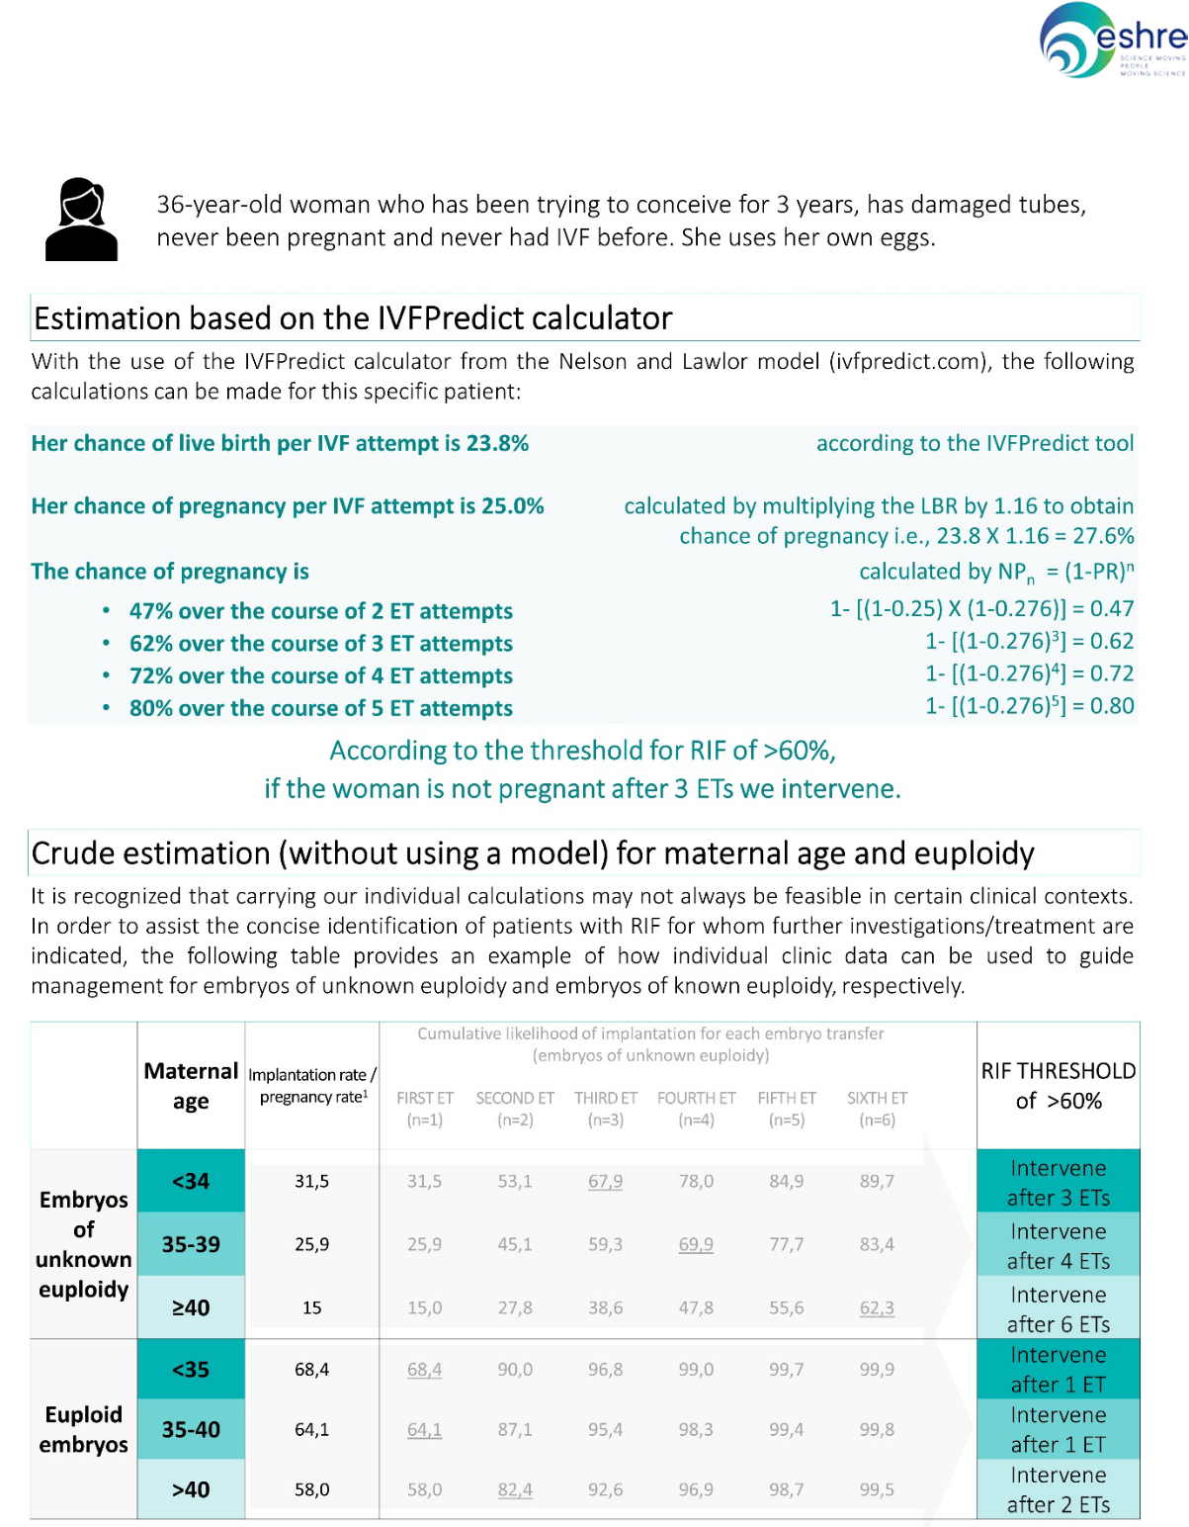
181 Figure 2. Applied Example (Reig, et al., 2020, Wyns, et al., 2021)
182

Figure 3. Summary: Applying an individualised RIF definition in clinical practice
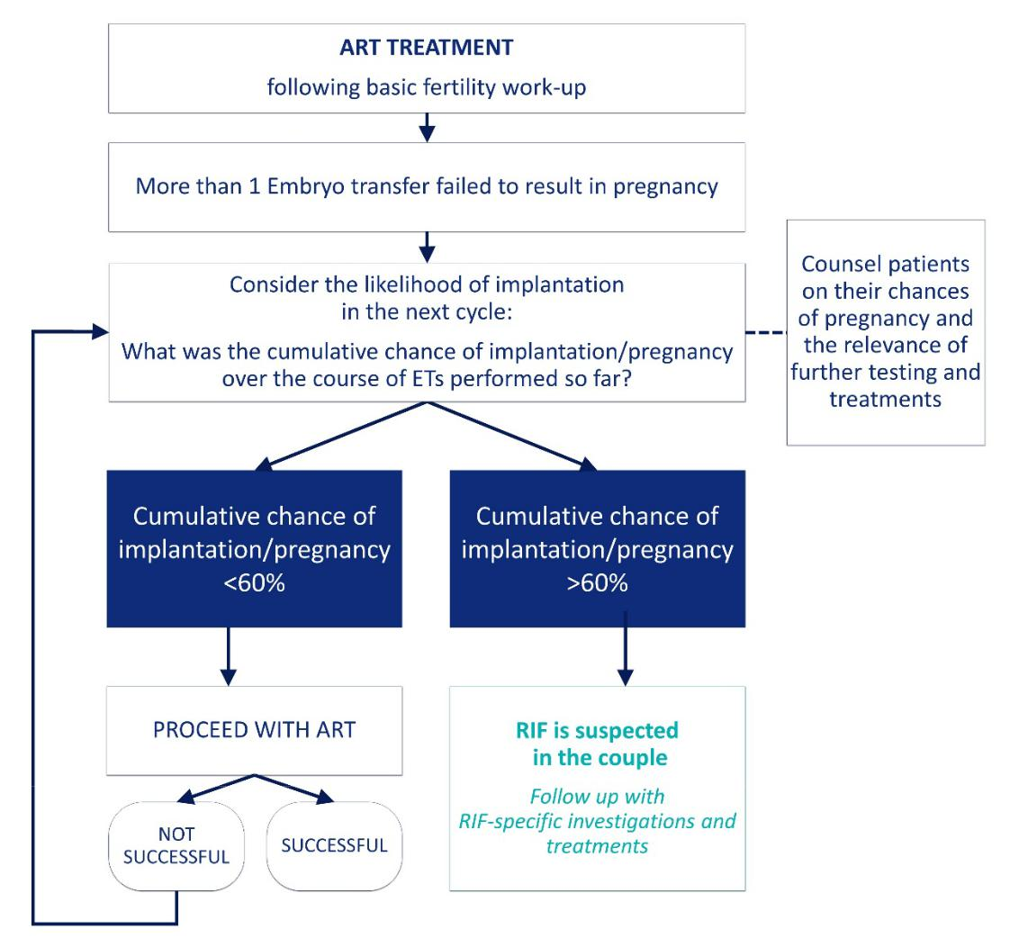

8

Investigations and treatments for RIF

Figure 4. Summary of RIF investigations

If RIF is suspected in the couple

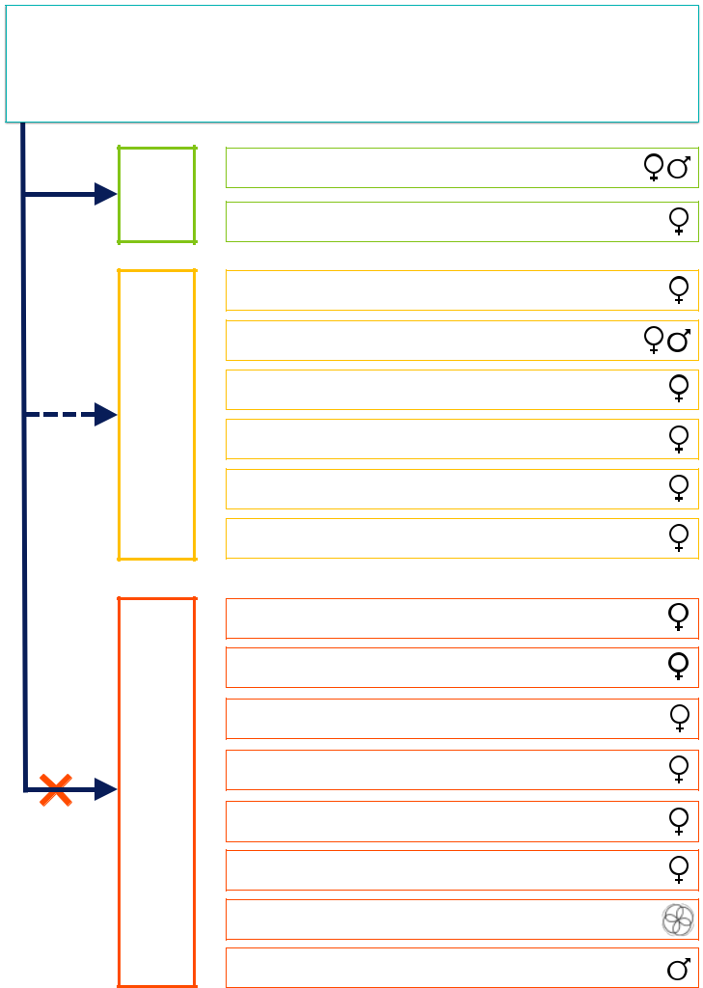
Follow up with RIF-specific inves�ga�ons

MENDED RECOM-

CAN BE CONSIDERED

NOT RECOMMENDED

Re-assessment of lifestyle factors

Re-assessment of endometrial thickness

Vitamin D

Karyotyping (both partners)1

3D US/hysteroscopy

Chronic endometritis

Assessment of thyroid function

Progesterone levels

Endometrial receptivity tests

Microbiome profiling

Peripheral NK cell testing

Uterine NK cell testing

Assessment of HLA-C compa�bility

Thrombophilia screening (APA/APS)2

Assessment of mtDNA content

Sperm DNA fragmenta�on/ FISH analysis

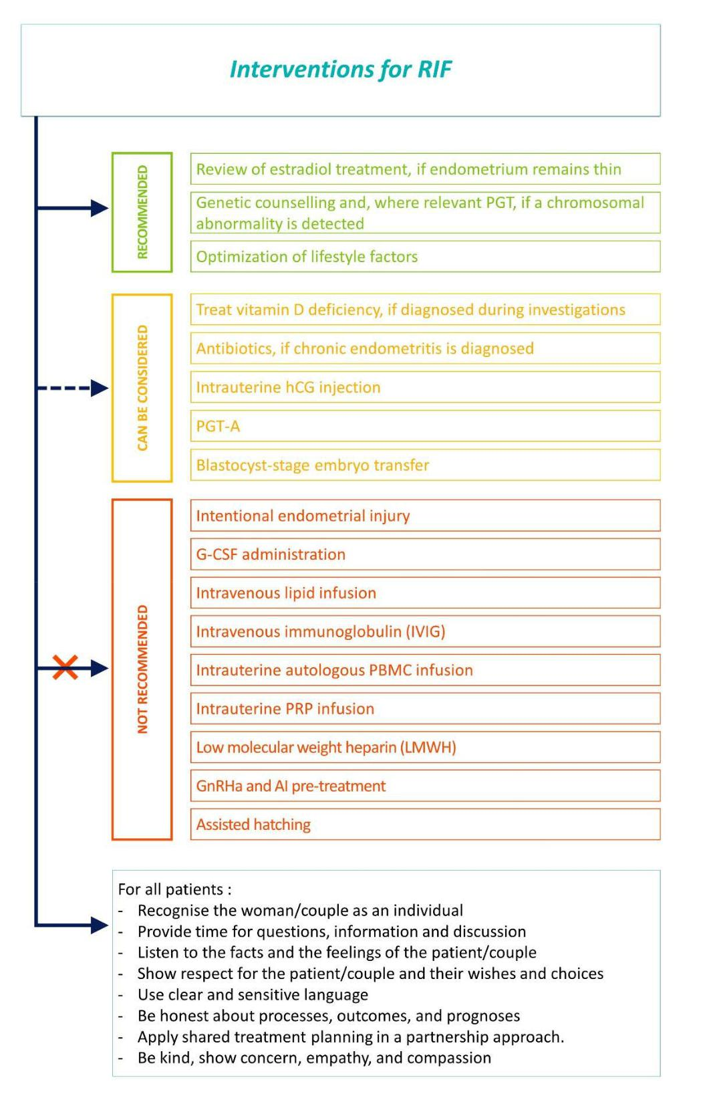
Treatments independent of investigation

